Attendance App: Assignment to be performed for demo to Arvind

Admin App. – This is a Web app in Angular clarity.  
Create 2 forms - 1. Student registration form, 2. Teacher Registration form

Student registration form:  
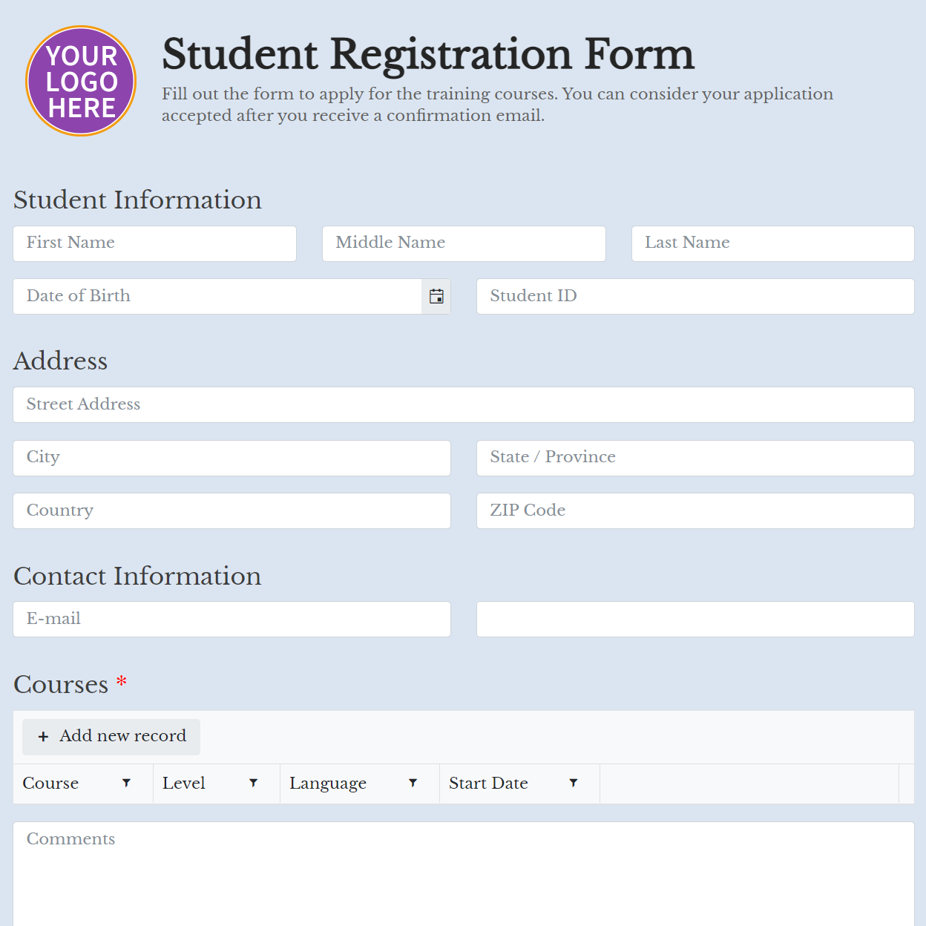

Teacher Registration form:  
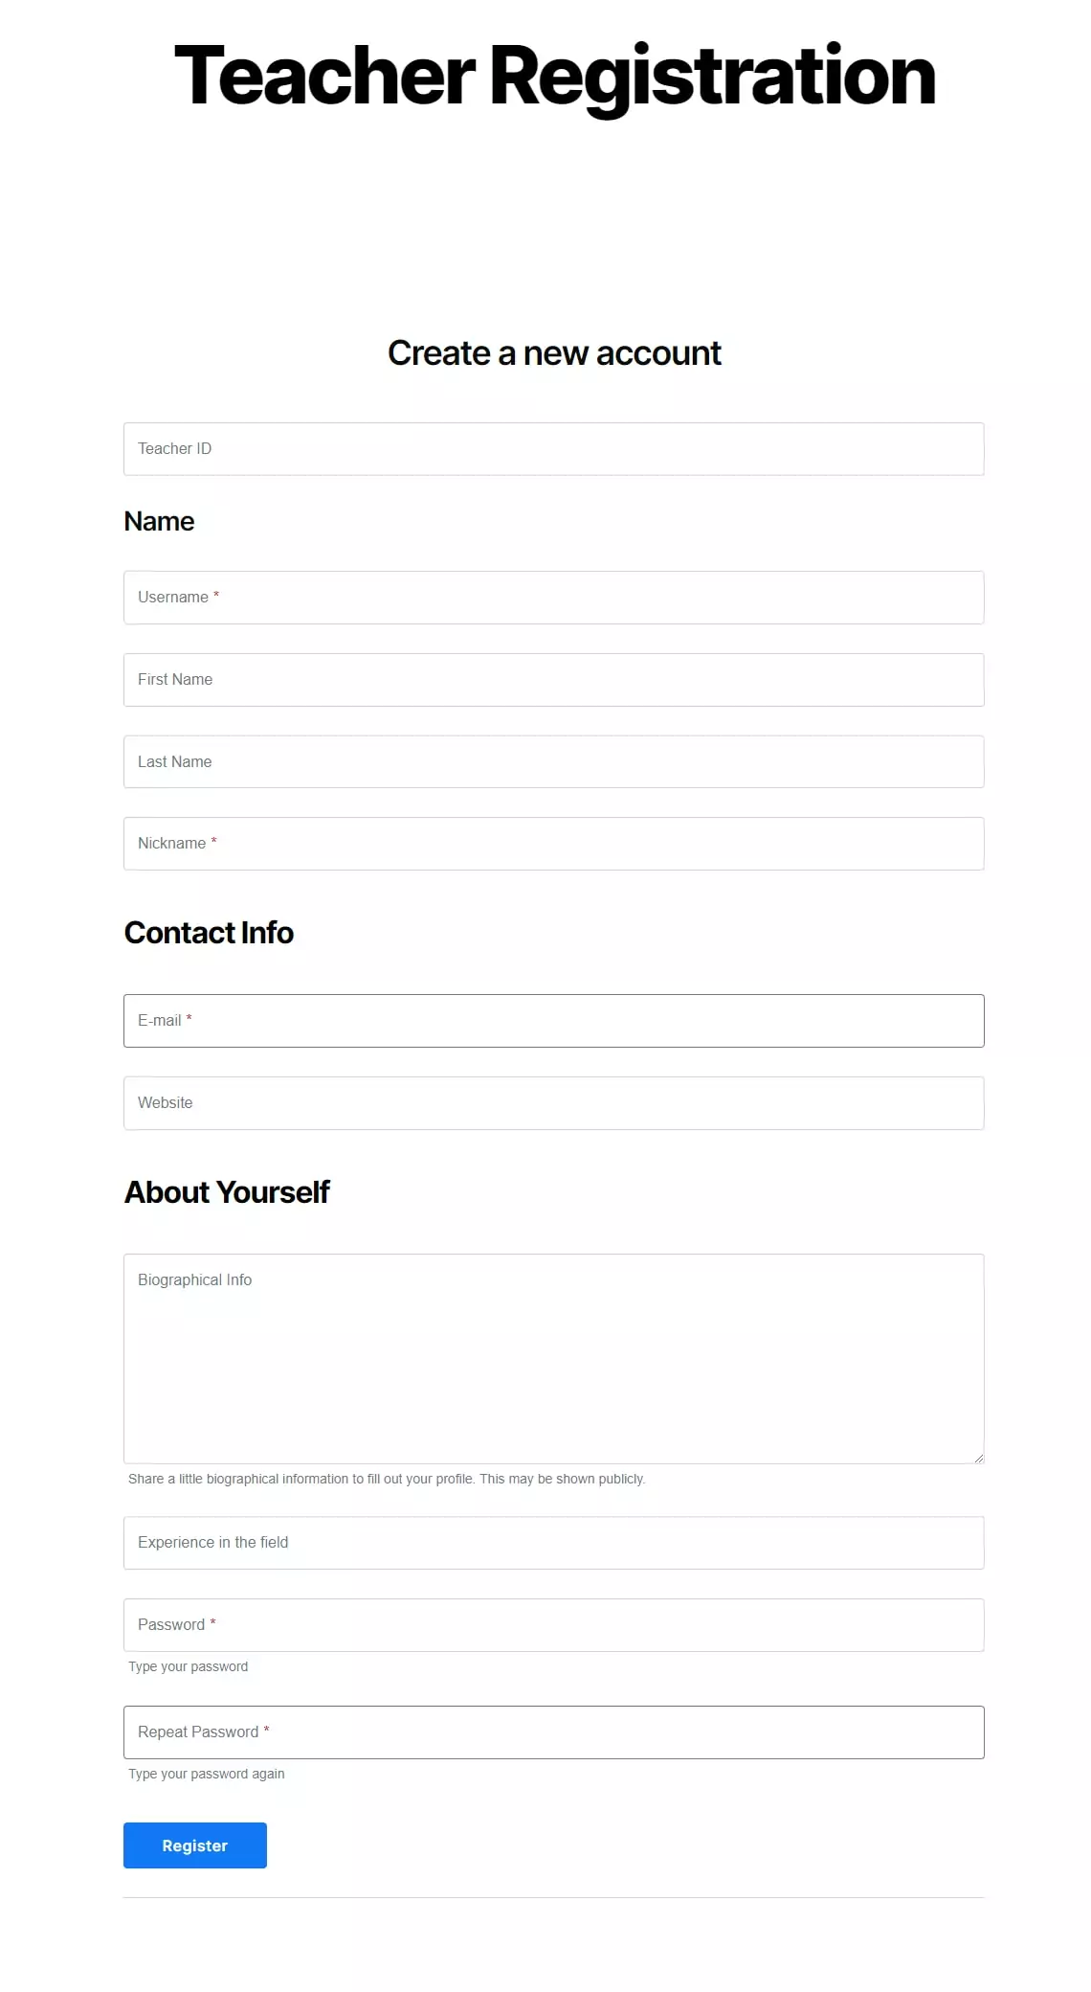

Add Courses to teachers - as a one-to-many relationship with teacher id. One teacher can have multiple courses.  
  
Courses in the above form is a master and is used in the form as a drop-down.  
  
**Attendance app for Teachers: This is a Flutter app built for Android**

Teachers will select a date and course name to generate a QR code – this QR code will have a random number generated by the app along with the date, and course name embedded in it and will be printed by the teacher to affix on the wall of the class.

This app will have a report to show students attending classes with parameters as date range and course name  
This app will have a dashboard to show students attending classes and with parameters as date range and course name

**Attendance app for Students: This is a Flutter app build for Android**

Attendance form will allow every student to scan QR code and add their own attendance for any course class when they attend the class.

This app will have report to show students attending classes and with parameters as date range and course name